Welcome to All Saints’

Queen’s Park, Bedford 02.08.2020

Our Church Mission:
To be a welcoming growing Church for
everyone regardless of age, race, creed.
To be a Church of discipleship, mission,
and evangelism.

Today at All Saints’
At 10am you are able to come to Church and share in the online Zoom service with the many Church members who worship with us at home.
We shall continue, as in private prayer sessions to be socially distant. Hygiene precautions will be thorough and include the provision of hand gel on entry and exit points (routes are indicated by arrows).
For those in Church please note you will need to wear a face covering.
The service order will be displayed on a screen in church for us all to join in with the responses highlighted in bold. Please do not join in the singing but do feel free to hum along.
OR
Gather from 9.45am for our 10am Church Service today by Zoom.
https://us02web.zoom.us/j/2089643121?pwd=UmsrR3lwNWhzY3JES2w2UVF3Y2N4Zz09
Meeting ID: 208 964 3121 1918
Or by telephone. 0203 481 5240 or 0131 460 1196
Phil Macauley, a Durham student, and priest in training, will be preaching on the gospel reading and also leading our prayers. Welcome Phil and feel free to talk to him before or after the service on Zoom.
Revd. Kate Peacock, a colleague of Fr Paul's in the Flourishing Churches Team, is hoping to be with us today, either by Zoom or in Church.

Our Intercessions for today.

Heavenly Father, thank you that you provide enough for us. Thank you for sending your Son for our redemption, thank you for sending your Spirit to give us life. Thank you for giving us the opportunities we have to bring life and hope to others, and to be your means of sharing so that all may have enough. Thank you, Father, for all you have provided.
Lord, in your mercy, hear our prayer.

We pray for our church family, taking a moment to pray silently for all we know suffering with illnesses or struggling with health issues through this time.(pause) We pray that you would bring your healing, through medicine, through our care, and by your Spirit.
Lord, in your mercy, hear our prayer.

We pray for our church parish, and the wider churches of our town, to have enough resources and courage to flourish for your Kingdom. Would you forgive us all for our mistakes, fear, and distractions. Have mercy upon us and all the people in our neighbourhood. Stir your church by the power of your Spirit to have enough strength to know and share your great love, and to lead transformation that will see you build your Kingdom in our midst.
Lord, in your mercy, hear our prayer.

We pray for the world to be united in the fight against the coronavirus pandemic. Please would you bless the scientists and medical professionals with all they need to provide a vaccine and the care that is needed for every patient. Would your church stand against those who would sow fear, mistrust and hatred through this time. Would the shared pain and concern caused by this pandemic lead to more and more people growing in love and faith together. Come Lord Jesus!
Lord, in your mercy, hear our prayer.

A prayer from Thomas a Kempis:
Grant me, O Lord, to know what is worth knowing,
To love what is worth loving,
To praise what delights you most,
To value what is precious to you,
And to reject whatever is evil in your eyes.
Give me true discernment,
So that I may judge rightly between things that differ.
Above all, may I search out and do
What is pleasing to you;
Through Jesus Christ our Lord. Amen.

Notices for the week:
Sunday Night Cap Natter tonight 7.30pm to 8.30pm.
Joining instructions are the same as for the Sunday Service.
The question for discussion tonight:
"Who would you invite as a dinner guest and why?"
Monday and Saturday: Church open between 11am and 1pm for personal prayer. The Sacrament will be available on Saturday either to be self-administered in church or taken away.
Please note the church will not now be open on Fridays.

Caroline will be singing in Church from 12.00 to 12.30 on Monday.
Do come and listen if you are free.

Monday at 6.30pm Camino Prayer – log in as for Sunday Service.

Thursdays in August. Starting at 10am on Thursday this week,
Revd Jane Bass will preside at a service of Holy Communion in the main body of the church. It is also the Feast of the Transfiguration that day, a special occasion. If you feel able to do please come along, it will be a great start to the lifting of another piece of lockdown.
All current restrictions will be observed.

Thursday: Night Prayer 8.15 to 8.45pm.
Dial: 03300 945 940 Room: 92067845# Guest PIN: 4104#
Click on the link for the Night Prayer Order of Service:
http://allsaintsbedford.co.uk/wp-content/uploads/2020/04/NIGHT-PRAYER-v2.pdf

Bible Study at 6.30pm on 7th August. Do take this opportunity to join with others and explore the gospel. Joining details as for Sunday service.

Forthcoming Notices:
Camino Prayer at 6.30pm on Friday 14th August.
Log in as for Sunday service.

All Saints Parish Church is inviting you to a scheduled Zoom meeting.
Topic: Meet the Bishop of the Windward Islands
Date: at 7:30 on Tuesday 11th August (UK Greenwich Mean Time)

His Lordship, The Rt Revd C. Leopold Friday, BA, MA
Bishop of the Windward Islands.
Very Important. Not to be missed! Join us for a unique opportunity to speak to and listen to, the current Bishop of the Windward Islands in the Caribbean, The Rt Rev Bishop Leopold Friday. Share greetings, concerns and experiences of Coronavirus lockdown season here and in the Caribbean, building and affirming relationships in our Church communities.

Join Zoom Meeting
https://us02web.zoom.us/j/2089643121

Meeting ID: 208 964 3121
One tap mobile
+442039017895,,2089643121# UK
+441314601196,,2089643121# UK

Dial by your location
+44 203 901 7895 UK
+44 131 460 1196 UK
+44 203 051 2874 UK
+44 203 481 5237 UK
+44 203 481 5240 UK
Meeting ID: 208 964 3121
Find your local number: https://us02web.zoom.us/u/kbIf1PQ5qL

The Lord's Prayer Project
All Saints Church Family can you say the Lord's Prayer in a different language, dialect or accent? If yes, contact Sarah Ibrahim Mob: 07872147450 to support our new project.

Flourishing Churches Team
Go online and enjoy the content at home with your family.
Details include: Children’s Ministry, Family Resources
https://www.stalbans.anglican.org/faith/living-gods-love-at-all-times/#Liturgy

All Saints Congregation WhatsApp Group Survey
All Saints would like to thank you all for completing our short survey last week on the AS Congregation WhatsApp group, your feedback has been fantastic. We have reviewed your responses, please see summary below. Any further feedback please WhatsApp or text Sarah Mob: 07872147450. Thank you all for your contributions and God Bless.

Q1: Do you wish to continue receiving the Prayer for the Day?
52 responses; 2 No; 50 Yes

Q2: Should we replace the ‘Prayer of the Day’ with a ‘Prayer of the Week’ posting once a week or continue daily?
50 responses; 42 Weekly; 8 Daily

Q3: Have you found the AS Congregation WhatsApp Group useful? Please include a brief answer and include suggestions for anything you would like us to consider changing.
30 responses
In summary, everyone finds the AS Congregation WhatsApp Group very useful, it has been a comfort receiving the morning prayers to start their day and they enjoyed the variations of text, modern inspirational music and prayers which catered for different people.
It has been useful for staying connected to each other and in faith. Many have shared postings with others outside of All Saints who have appreciated sermon links and prayers.
It keeps us bonded together with the church and our church community. Helping us to keep a connection when we might think we have lost the connection. Our faith, during the Coronavirus pandemic, is strengthened through this communication, especially as some endured low, difficult and stressful times.
“We feel that we haven't been forgotten by the Lord.”
Responses to be considered by the AS Communications Ministry team will include:
Perhaps more updates on how individuals are doing.
Connectivity is important for resilience in these times.

Volunteer Guides needed to show schoolchildren around our Church and introduce them to the Christian faith – on Tuesdays and Wednesdays (term time). Contact Petra (yatesp101@gmail.com) or Debbie (07767 470528 or wardclan@btopenworld.com) to find out more about becoming a guide, or other ways to help.

Fusion Youth Choir online.
Keep singing and learn new skills with our Choir Director, Miss Jo. The sessions are held on Fridays 4pm via Zoom. Please email jo@justpurplepresents.co.uk with your email address.

Bedford Food Bank are still open to receive food donations at their depot at 71, Murdock Road, Manton Industrial Estate, Bedford MK41 7PL between 10am & 12 noon Monday to Friday.


The National Church Daily Hope phone line aimed at those who do not have access to the internet.
The line is available 24 hours a day on
0800 804 8044. This is a simple way to bring worship and prayer into our homes.

Thank you! We are grateful to the lawn cutting team: Maggie, Ralph & Roger and to Jim & Pauline for the begonias outside Church.

Prayer for the Week from Irmela.
Father of everlasting goodness, gifts without measure flow from You.
Fill us to overflowing to meet the needs of Your community. Make us a caring church which comforts the grieving, prays for the sick and needy, welcomes those pushed aside or rejected knowing that this is our everlasting gift to You. We ask this in Jesus name. Amen.
Thought for the week:
"God's generous giving and our wise using must go hand in hand."
Dr William Barclay (Scottish professor and preacher)


Lectionary Readings for today:
Isaiah 55: 1-5
Matthew 14: 13-21

Lectionary Readings for next week:
Psalm 85: 8-13
Matthew 14: 22-33


Requests for inclusion in ‘Prayers for those in Need’ for whatever reason should be sent to Diane watts4dx@btinternet.com.

If you would like the anniversary of your loved one's death to be included in the ‘Year's Mind List’, please give their name and the date to Diane.

Prayers for those in Need.
David Bach, David Butson, Ann Fortune, Mavis Green, Kate King,
Yvette Lendore, Venus Masih, Jacob Nicholson, Nina, Lily-May Perkes, Jackie Simpson

Phil Meredith thanks his church family for all their prayers in recent months.

Recently departed: Vanetta Johnson, Ralph Ames

Year’s Mind: Gladys Litchfield, Joy Sheridan Makin, Ann Bedeau, Adrian Wallace, Darrell Jeffreys, Irene Clark

Birthdays: Emma Gorham (5th), Olive Nelson (8th)

Ways of keeping in touch.

If you have any Parish enquiries, please contact:
Parish Priest: Fr Paul Davies 07414 011 793 or allsaintsfrpaul@gmail.com
Reader: Sarah Ibrahim 07872 147 450 or saidit07@outlook.com
Churchwardens: Rosemary 01234 328745 or stephen.buckle541106@yahoo.co.uk
Roy 07595 591 902 or roy.lambert@openreach.co.uk
Website: www.allsaintsbedford.co.uk Facebook: AS Church
Items for the bulletin to asbulletin@hotmail.com by
9am Thursday mornings please.

Our musical Director Caroline is including some of our ‘Favourite Hymns’ in Sunday services.


Our Favourite Hymns
I the Lord of Sea and Sky
Thine be the glory.
Christ’s is the world in which we move- a touching place
For the might of thine arm we bless thee
Lord Jesus in days of old two walked with Thee.
How shall I sing that Majesty?
Sweet Sacrament Divine
I vow to thee my country
Be still for the spirit of the Lord
Abide with me
Make me a channel of your peace
How great thou art.
Thine be the glory.
What a friend we have in Jesus
10000 Reasons Bless the Lord
O worship the Lord in the beauty of holiness
Make me a channel of your peace
Dear Lord and father of mankind
Shine Jesus Shine
He's got the whole world in his hands
Amazing Grace
Great is thy faithfulness
When I survey the wondrous cross
O the love of the Lord is the essence
Come thou long expected Jesus
Eternal Father strong to save
Will your anchor hold
The old rugged cross
The day thou gavest

These are the choices made by those who responded to the recent invitation to identify their favourite Hymn.
If you missed your chance, please contact Petra.

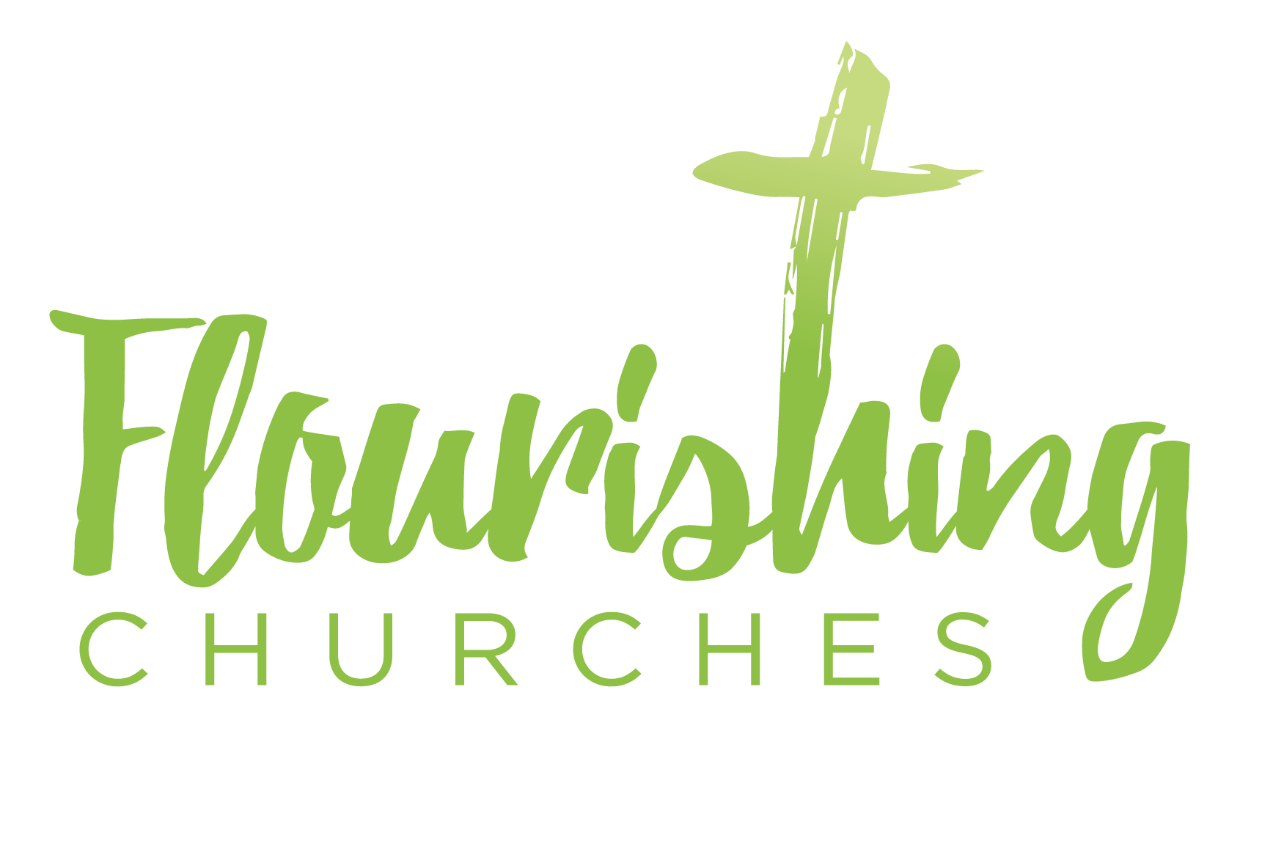
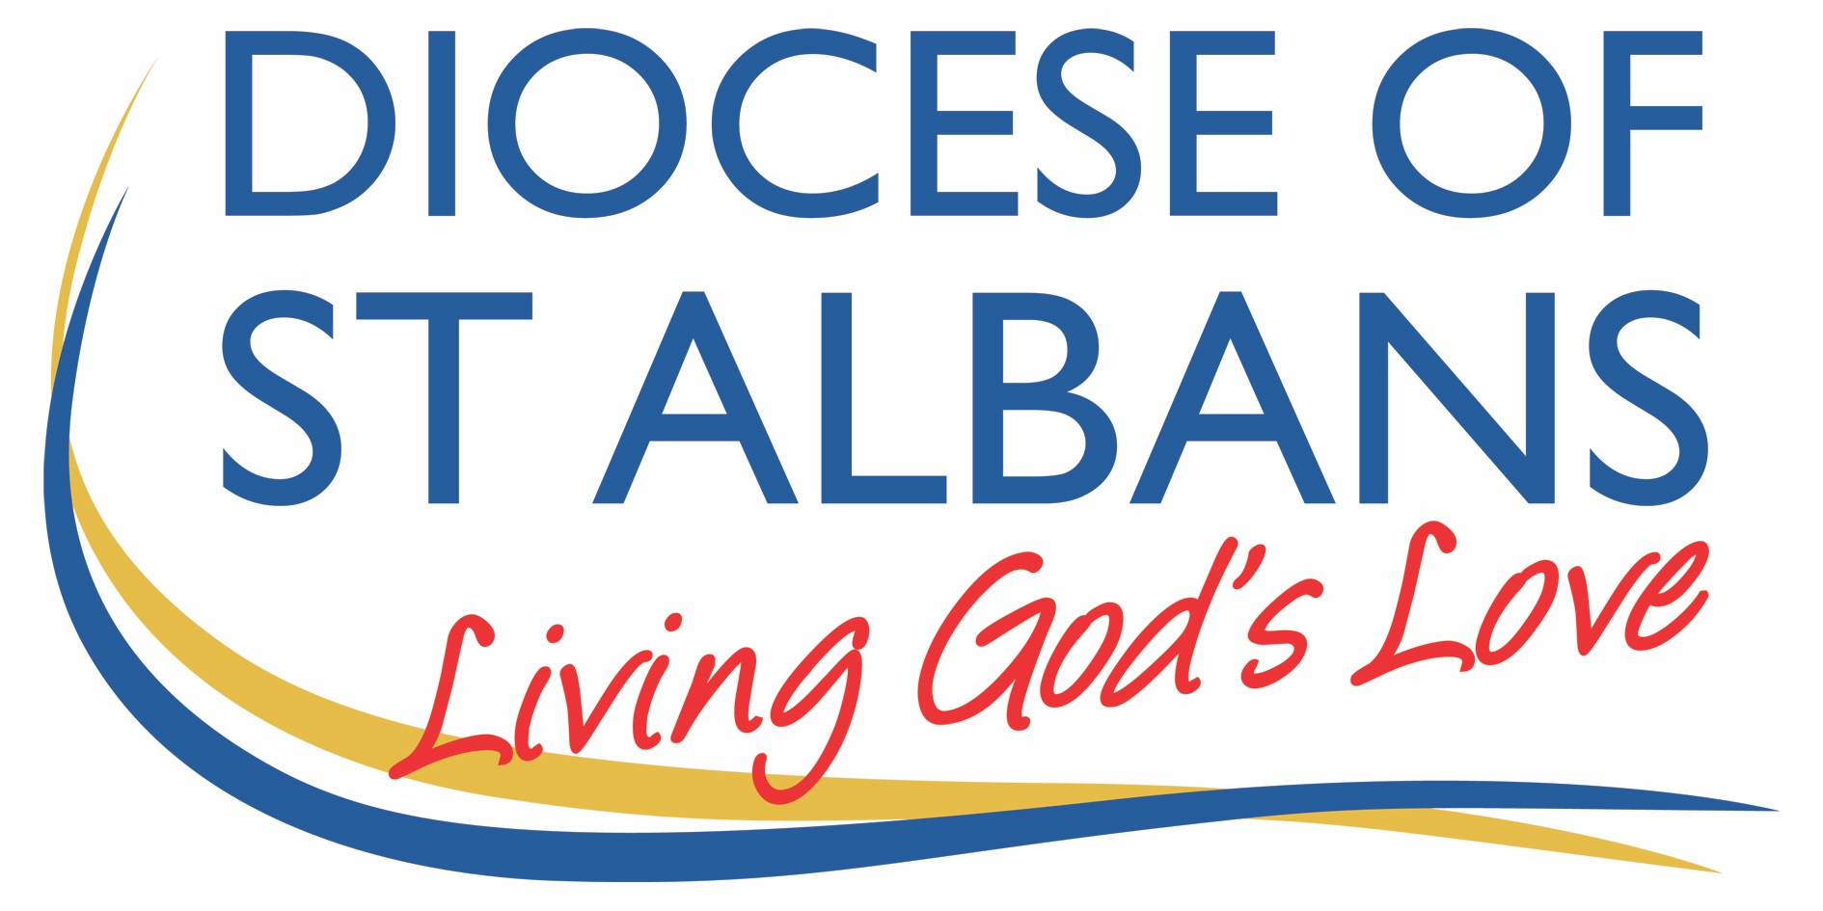

Sunday 2nd August: Trinity 8 Matthew 14 v13-21

Welcome to Praying Together but Separately

Some hymns here from St Martin’s in the Field:

https://www.achurchnearyou.com/hub/asset/hymns-and-choral-music

Gathering Before God

Make sure you are sitting comfortably.

I am in the presence of the Living God, Father, and of the Son, and of the Holy Spirit. Amen.

Prayer of the Day

Lord God,
your Son left the riches of heaven
and became poor for our sake:
when we prosper save us from pride,
when we are needy save us from despair,
that we may trust in you alone.
Through Jesus Christ our Lord. Amen

Reflection

Breathe slowly and deeply.
Ask God to speak to you through the passage that you are about to read.

Bible Reading: Matthew 14 v13-21

Now when Jesus heard this, he withdrew from there in a boat to a deserted place by himself. But when the crowds heard it, they followed him on foot from the towns. When he went ashore, he saw a great crowd; and he had compassion for them and cured their sick.
When it was evening, the disciples came to him and said, ‘This is a deserted place, and the hour is now late; send the crowds away so that they may go into the villages and buy food for themselves.’ Jesus said to them, ‘They need not go away; you give them something to eat.’ They replied, ‘We have nothing here but five loaves and two fish.’ And he said, ‘Bring them here to me.’ Then he ordered the crowds to sit down on the grass. Taking the five loaves and the two fish, he looked up to heaven, and blessed and broke the loaves, and gave them to the disciples, and the disciples gave them to the crowds. And all ate and were filled; and they took up what was left over of the broken pieces, twelve baskets full. And those who ate were about five thousand men, besides women and children.

Read through the passage once. Read it quietly out loud but say each word out loud.
Try and take note of any words or phrases that strike you.
Say that word or phrase quietly out loud or underline it with a pen.
Read the passage a second time.
As you read, think about how the word or phrase you notice might speak to you today.
After you have read the passage again, sit in silence and try and come up with a sentence or two that sums up what you think the word or phrase means for you today.

Read the passage a third time and prayerfully think about what Christ has said to you.

Some thoughts for Further Reflection:

It may feel like an odd time to be reflecting on the abundance of God and the miracle of the feeding of the 5000 men plus women and children. It sits as an odd counter point to our current lives which are full of constraint, guidance, guidelines, cancelled events, frustrations, and deep anxiety for the future; as well as the profound grief we feel for those who we have loved and lost.

And yet, here is Jesus attending to the detail of the crowd’s hunger – attending to their need for food and rest. He knows you cannot listen, learn, grow in your souls when your belly is empty. You cannot fully engage when you are distracted and not at peace. Many of us may not have experienced serious physical hunger, when we are so concerned for our next meal, we cannot settle to anything.
We have all known the rumbles and pangs when lunch is late or dinner delayed, but the crowd had travelled and followed Jesus all day – their sick had been cured – it had been a long day, they had walked miles and they were pretty hungry and far from home. And Jesus wasn’t finished with them – ‘they need not go away’. He wanted them to stay despite his own tiredness and need for solitude at the start of this story. His compassion was greater, his love wanted to nurture them in body and soul. So 2 fish and 5 loaves were found – someone’s picnic maybe (John’s Gospel has them handed to Jesus by a young boy) and somehow all were fed and all were satisfied. God multiplied the food so there was enough – bellies were full so their hearts could be filled too. Conversations could be had. The people could spend more time with Jesus and his disciples. And there were leftovers – 12 baskets to represent the 12 tribes of Israel. Enough for everyone.

So, this miracle of abundance tells us of God’s love, power and compassion. And also, God’s practicality – we are human bodies with physical needs and God knows that and shares that with us. Our hunger at this time for contact, hugs, spontaneity, freedom are known by God and understood by God. All the things we have given up containing the virus are known and seen and heard by God. And God calls us to fullness of life and God shows us that He knows our needs – physical, emotional, and spiritual. And God attends to them; God offers us food and rest. Rest in the knowledge of his love. Food in the words of the Bible, the food of God’s saving work and love amongst us in Jesus. Food in the Spirit who nurtures us and empowers us. We may experience all these things in particular ways. A kind word from a friend, an email or letter encouraging us. We may feel our hearts swell as we pray or sing or take a walk in God’s creation. When we find time to ‘stop and stay a while’ and open ourselves to God perfect presence we can find a deeper rest, and a peaceful restoration of our souls. God knows how hard life is now and how hard it can be for all his children – and he meets us in that and offers us food and love.

Creative Prayer activity for at home

List all the things you have given up in the last 4 months: birthdays, weddings, family gatherings, work, hugs with loved ones etc… List them here or say them aloud. Maybe look through your calendar or diary.
Offer these things to God – the events, the sadness, the frustration. This prayer may be useful:

Loving God you know my needs better than I do myself. Hear me in my frustration, my sadness, my grief. My losses are painful and hard to bear. Be with me now as I admit them to myself and to you. I pray you will heal my deep wounds and grief and my surface wounds of irritation, lack of patience and annoyance. Help me to grow in compassion for myself and those round about me. I pray that as you fed the crowds you will feed me with your love and your Holy Spirit. Amen.

A prayer concerning the Coronavirus

God of compassion,
be close to those who are ill, afraid or in isolation.
In their loneliness, be their consolation;
in their anxiety, be their hope;
in their darkness, be their light;
through him who suffered alone on the cross,
but reigns with you in glory,
Jesus Christ our Lord. Amen.

An act of spiritual Communion

My Jesus,
I believe that You
are present in the Most Holy Sacrament.
I love You above all things,
and I desire to receive You into my soul.
Since I cannot at this moment
receive You sacramentally,
come at least spiritually into my heart.
I embrace You as if You were already there and unite myself wholly to You. Never permit me to be separated from You. Amen.

The Lord’s Prayer

Our Father, who art in heaven, hallowed be thy name;
thy kingdom come; thy will be done;
on earth as it is in heaven.
Give us this day our daily bread.
And forgive us our trespasses,
as we forgive those who trespass against us.
And lead us not into temptation; but deliver us from evil.
For thine is the kingdom,
the power and the glory, for ever and ever. Amen.

